Diversity and dynamics of Culicoides populations associated with livestock in France

Results
- Trapping effort
  - Initial traps
- 207 traps
- 14,906 collections
- At least 83 species
- 6,281,973 individuals
> summary(SaDe$NoCollections)
Min. 1st Qu. Median Mean 3rd Qu. Max.
4.00 49.00 86.00 71.98 97.00 104.00
> summary(SaDe$NoYear)
Min. 1st Qu. Median Mean 3rd Qu. Max.
0.000 2.000 4.000 3.111 4.000 4.000
> summary(SaDe$MeanNoValidMonthByYear)
Min. 1st Qu. Median Mean 3rd Qu. Max.
0.000 6.000 6.500 6.244 7.000 7.000
> summary(SaDe$MinNoValidMonthByYear)
Min. 1st Qu. Median Mean 3rd Qu. Max.
0.000 5.000 6.000 5.488 7.000 7.000
> summary(SaDe$MeanNoYearByValidMonth)
Min. 1st Qu. Median Mean 3rd Qu. Max.
0.000 1.929 3.429 2.868 3.857 4.000
> summary(SaDe$MinNoYearByValidMonth)
Min. 1st Qu. Median Mean 3rd Qu. Max.
0.000 1.000 3.000 2.329 3.000 4.000

  - Selections
    - 171 traps (at least 2 years of surveillance AND at least 1 collection from April to October)
- > temp <- aggregate(No_Ind ~ ID_Trap + Year, FUN=sum, data=Tab)
- > summary(temp$No_Ind) ; hist(log10(temp$No_Ind+1))//
- Min. 1st Qu. Median Mean 3rd Qu. Max.
- 0 1325 3867 9973 10310 266800

- > temp_Min <- aggregate(No_Ind ~ ID_Trap, FUN=min, data=temp)
- > summary(temp_Min$No_Ind) ; hist(log10(temp_Min$No_Ind+1))
- Min. 1st Qu. Median Mean 3rd Qu. Max.
- 0.0 515.5 1541.0 3575.0 4292.0 47010.0

- > summary(temp_Max$No_Ind) ; hist(log10(temp_Max$No_Ind+1))
- Min. 1st Qu. Median Mean 3rd Qu. Max.
- 56 3649 9146 18610 18540 266800

- > temp <- aggregate(No_Ind ~ ID_Trap + Date, FUN=sum, data=Tab)
- > temp_Max <- aggregate(No_Ind ~ ID_Trap, FUN=max, data=temp)
- > summary(temp_Max$No_Ind) ; hist(log10(temp_Max$No_Ind+1))
- Min. 1st Qu. Median Mean 3rd Qu. Max.
- 21 1628 4375 9863 8744 163700

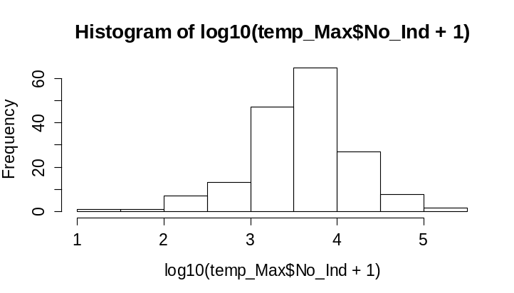

    - 169 traps selected (at least 100 Culicoides collected once)
      - 14,035 collections
      - At least 82 species
      - 6,152,805 individuals

    - Aggregate data into maximum of female abundance
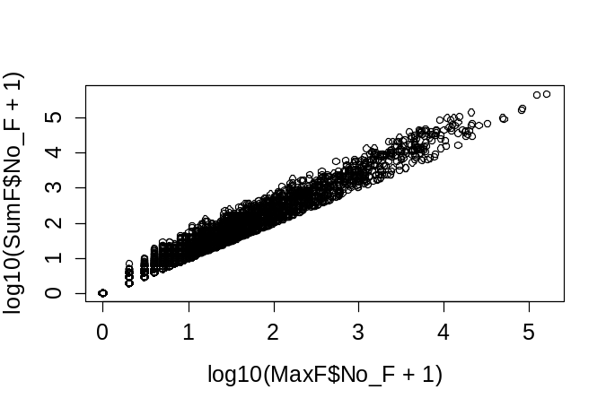
      - Delete obsoletus s.st, scoticus s.st, Culicoides sp. and derisor (0 female)
      - Thus, 80 species
      - 1,862,519 females (from data of the maximum abundance ever observed)
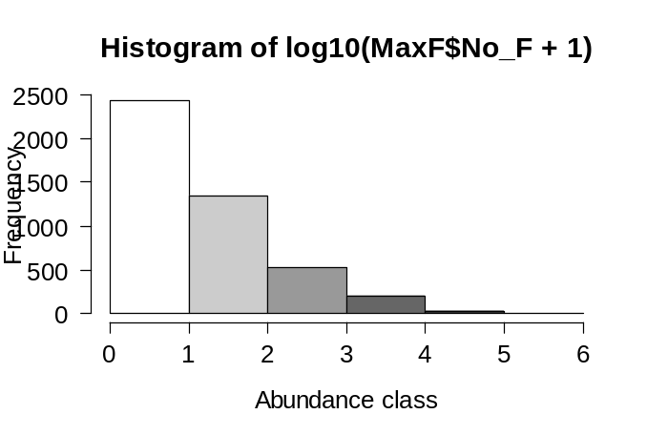
Maps for the main Culicoides species
XX
Frequency histograms: species occurrences and relative frequencies in the 169 sites
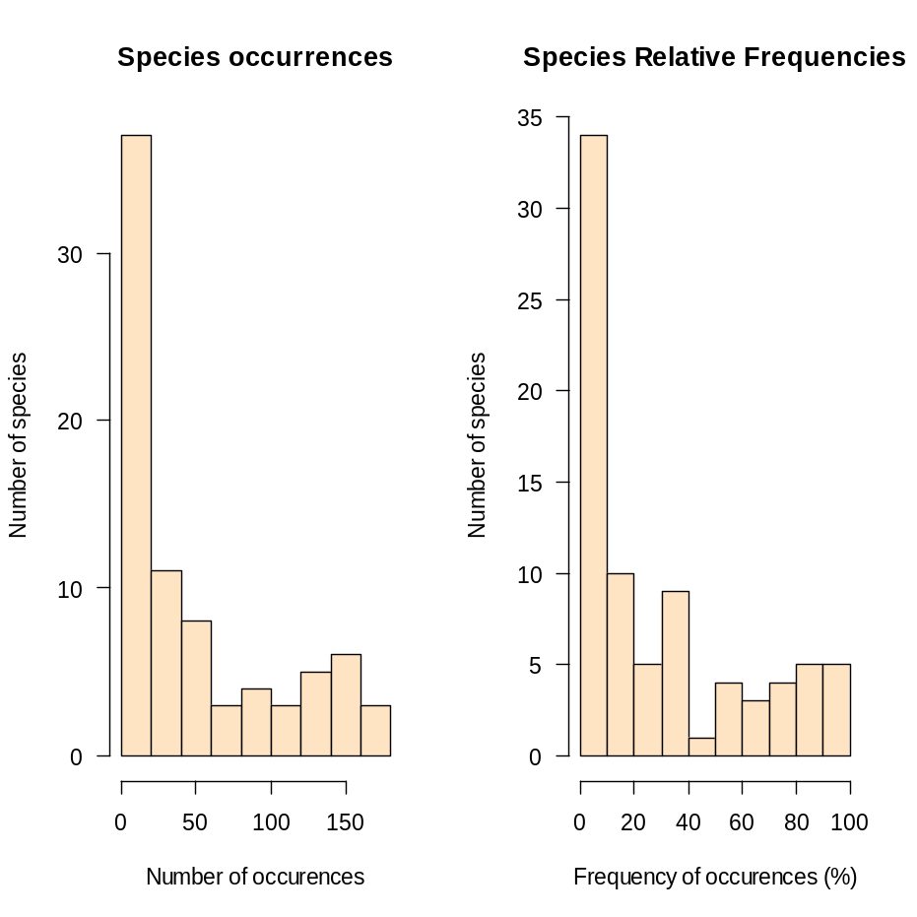
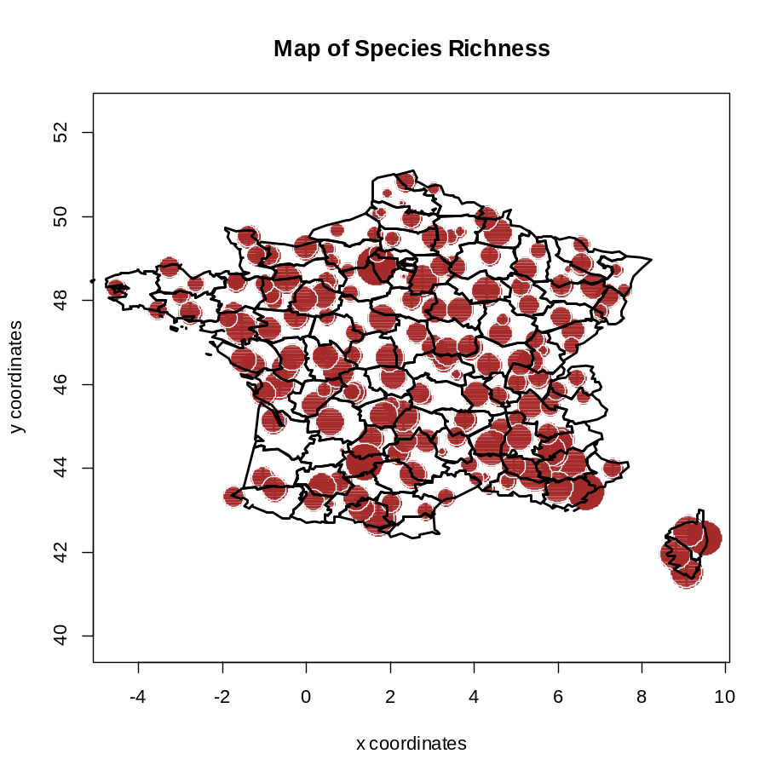

> cor.test(Trap$Y,div$N0)

Pearson's product-moment correlation

data: Trap$Y and div$N0
t = -4.2934, df = 167, p-value = 2.976e-05
alternative hypothesis: true correlation is not equal to 0
95 percent confidence interval:
-0.4450644 -0.1725397
sample estimates:
cor
-0.3152875

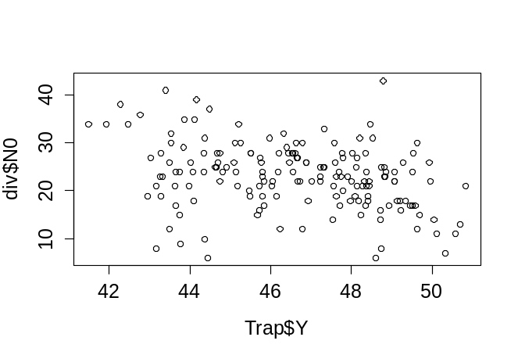

Dissimilarity matrix on raw abundances
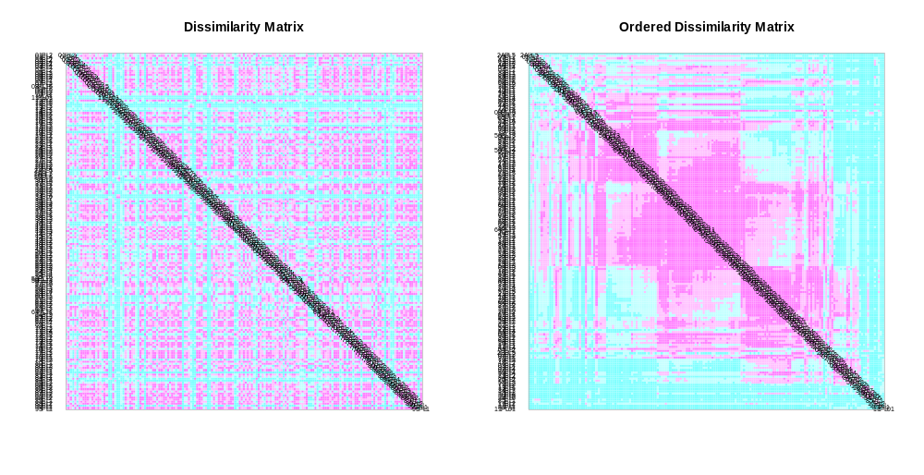

- List of species
- Partial triadic analysis: stability of diversity over years
- Difference with wildlife associated Culicoides
- Biodiversity indices//tableau faunistique brut
- Abundance of species along a gradient (North-West to South-East)
- Map with krigeage
Could be in another paper
- Dynamics by climatic zones
- Inactivity periods and temperature

